**COMSATS University Islamabad, Abbottabad Campus**

**Department of Computer Science**

**Project Proposal**

**E-Voting System**

**CSC392 Object Oriented Software Engineering**

Submitted on: 18 oct 2022

Group Members:

Abid (SP21-BSE-085) **(Leader)**

Abdul Basit Yousufzai (SP21-BSE-092)

Ali Sina (SP21-BSE-089)

Abdul Basit (SP21-BSE-087)

Hayatullah (SP21-BSE-080)

Faisal Hassanzada (SP21-BSE-28)

Ahmad Ikhlas Safi (SP21-BSE-088)

Muhammad Bilal (FA20-BSE-071)

Ashiqullah (SP21-BSE-084)

Table of Contents

CHAPTER 1 PROJECT PROPOSAL 3

**Introduction** 3

**Vision and Business Case** 3

Use-Case Model 4

S 5

**Glossary** 5

CHAPTER 2 USE CASES 7

**Use Case Diagram** 7

**Brief Level Use Cases** 7

• **Abid (SP21-BSE-085)** 8

View Dashboard 8

**1.** **Abid (SP21-BSE-085)** 14

# CHAPTER 1 PROJECT PROPOSAL

## **Introduction**

There is a need to update voting technologies to improve trust, reliability, and convenience [1]. We introduce a novel system for electronic voting based on a public blockchain. This system ensures that encrypted votes on the blockchain are reliably counted, while ensuring voter privacy. The primary way voters cast their ballots is by using electronic voting stations, which will send the encrypted ballots to the blockchain.

We designed the system with the following criteria in mind, based on previous literature [2].

* Privacy - Keeping an individual’s vote secret
* Eligibility - Allowing only registered voters to vote, with each such voter voting only once
* Hiding interim results - Partial results should not be released during the voting period
* Verifiability - The ability to trust the vote tallying process
* Receipt-Freeness - Voters should be unable to prove to a third party that they voted in a particular way. This is required to prevent coercion [3]
* Convenience - Voters must be able to vote easily, and everyone who is eligible must be able to vote

## **Vision and Business Case**

We present a new electronic voting system that employs blockchain technologies along with cryptographic techniques to obtain verifiable results while still retaining voter privacy. At a high-level, a vote is encrypted and a proof of the vote is sent to a public blockchain from an electronic polling station. A centralized authority then decrypts all the votes and posts the tally along with a proof that the reported results are correct and the voter can check that their vote was cast.

## Use-Case Model

Following is the functional requirement of our system.

1. **Register**

The System should register the Voter and IEC (Independent Election Commission) after verifying it from the MPR (Ministry of population and Registration)

1. **Login**

The System should allow those users who are registered in the system and verified users can be login to the system through their valid ID.

1. **View Dashboard**

The Dashboard will view the details of the voter and IEC (Independent Election Commission) member.

1. **Add Election**

The IEC will be able to add election to the system and also its type of it whether it is presidential and parliamentary.

1. **View Election**

The IEC and Voter will be to see the election and also its type.

1. **Remove Election**

The IEC will be able to remove election after expiring time of the election.

1. **Add candidate**

The IEC will be able to Add candidate to the system after fulfilling the requirements of IEC.

1. **View candidate**

The Voter and IEC will be able to view candidate of his/her area.

1. **Remove candidate**

The IEC will be able to remove candidate if he/she doesn’t fulfill the requirement.

1. **Conduct Election**

The IEC will be able to conduct election after arranging an election type.

1. **Set voting area**

Areas will be set for voting so that the voters can easily be able to vote their candidate from their specific polling station.

1. **Set Polling station**

Stations will be set in specific areas where possible for population of that area to vote their candidate.

1. **Add Polling station**

The poling stations will be added according to needs and necessity of it which main reason can be population.

1. **Remove Polling station**

There may be condition that there will be more stations than population so the IEC will remove the extra stations.

1. **Search Polling station**

The IEC will be able to search the station if it had any problem and by fixing it online.

1. **Display Candidate**

The candidate will be displayed to voters and IEC so that both can see the candidates.

1. **Caste vote**

The voter will be able to select and vote to their favorite voter

1. **Generate Result**

The votes will be gathered and counted by IEC and will be announced.

1. **Logout**

The IEC will be logged out of the system after the result announced and election done.

## S

## **Glossary**

**IEC = Independent Election commission**

**MPR = Ministry of Population Registration**

**Risks list and Management Plans**

A critical aspect of project management is developing a risk assessment tool that realistically identifies possible sources of risk, considers any mitigating factors and provides appropriate responses. This will involve a full assessment of potential security risks, as these are among the most critical for an electronic voting and counting system and should be carefully considered; but other types of risk related to logistical or even legal issues should be considered as well.

Although each project will have its own risks, a risk plan should address:

* Unauthorized intervention of third parties in the voting process (hacking attacks)
* Risk of (large-scale) manipulation by (small group of) insiders
* More difficult to detect and identify the source of errors and technical malfunctions than with conventional procedures (lack of transparency and lack of understanding of the system by non-experts)
* Possibility that fully digitized system would fail to produce results and lack physical back-up records, making a public recount difficult or impossible
* Requirement of system certification. However, no widely agreed (international) standards for certification available
* Reduced level of control by EMBs; high dependence on vendors and technical expertise
* Need for additional voter education campaigns
* Risk of (loosing) public trust in the election/referendum process
* Increased costs (purchasing and maintaining of e-voting system)

Attempts to discredit the system by those with competing commercial or political interests

A risk management plan should be developed early in the project and should be made publicly available so as to increase public confidence in the election authorities’ ability to face the challenges of implementing electronic voting or counting.

Election observers should review the project management documents on an ongoing basis and highlight any gaps that they identify in a timely manner so that recommendations can be made to improve the project. Using the project documents, observers can also provide oversight to ensure that deadlines are being met and the project remains on track in terms of its timeline. Observers should also review the risk management plan to determine whether risks have been realistically anticipated and countermeasures devised. Observers are in a key position to provide this assessment of project progress to citizens on an ongoing basis through periodic statements. Such reporting can enhance public confidence in the election administration and also highlight any areas of concern in a timely manner so that action can be taken

# 

# CHAPTER 2 USE CASES

## **Use Case Diagram**

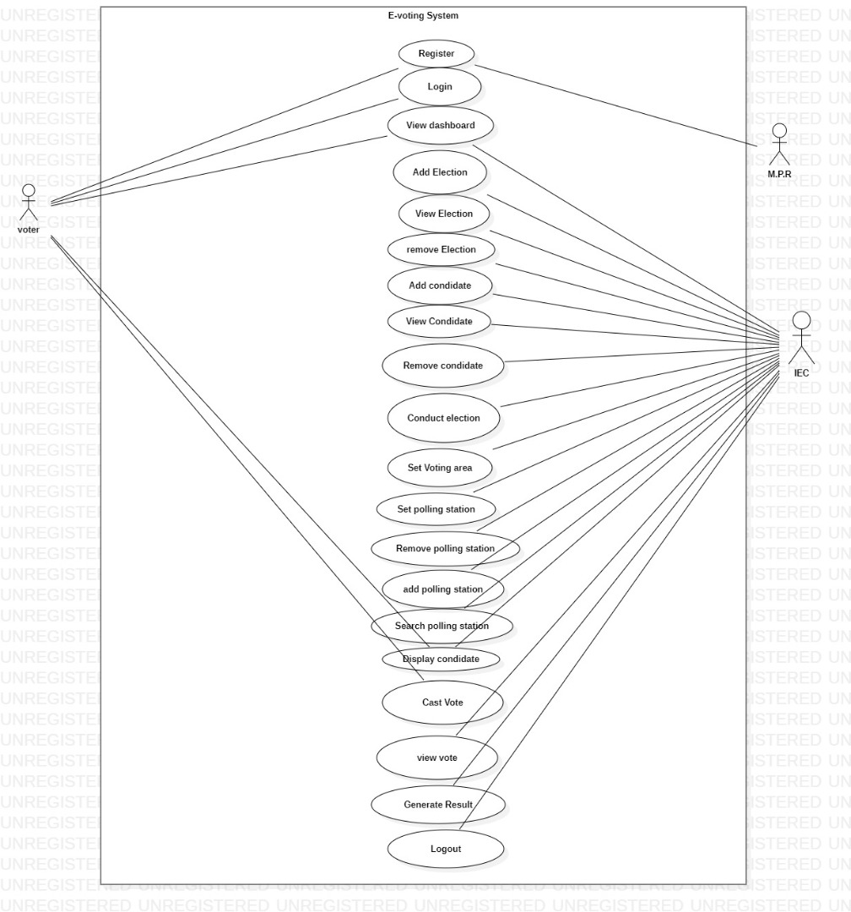

## **Brief Level Use Cases**

### **Abid (SP21-BSE-085)**

#### View Dashboard

|  |  |
| --- | --- |
| Use case section | Comment |
| Use Case Name: | View Dashboard |
| Use Case ID: | SP21-BSE-085 |
| Scope: | E-Voting System |
| Level: | User goal and sub function goal |
| Primary Actor: | User (Citizen) and IEC (Independent Election of Commission) |
| Stakeholder and interest: | **IEC (Independent Election Commission):** Wants to see the election time and also different feature of the system.  **User (Citizen):** Wants to see the candidates of his/area, polling station of his area and other candidates of his/her area. |
| Precondition: | * The user should have a stable internet connection in order to have access to this feature. * The user should have a valid login ID. * User is identified and authenticated |
| Success Guarantee: | * The different features of the system will appear and they can select the polling station of his/her area, candidates of his/her area, can view election, can caste vote and generate result. |
| Main Success Scenario: | * After clicking on the Dashboard, the dashboard will be appeared to the user. * The user status whether he/she voted or not * If he voted then the name of the candidate and the time in which he gave the vote will appear to the voter * For IEC, in dashboard election details will be appeared. * Number of registered voters will be appeared to him. * Number of qualified candidates and cleared will also appeared to the voter. |
| Extensions: | a: At any time, voter and IEC can be able to login into another system and can have access to other features   * The previous login ID will be log out from the system.   b: At any time, system fails:   * If the system fails, polling agent can be able to restart the system. * Voter can be able to login again in the system. * The IEC verify the voter and after verification give him/her the access to other features. * The voter can be able to log in into another ID * Another ID can be able to have access different features of the system. |
| Special Requirement: | * Touch screen User interface on a large flat panel monitor. Text screen should be visible from 1 meter. * Response of selection of area should be done within 30 seconds. * The 2 languages of the country Pashto, Dari should be displayed on the screen. |
| Technology and Data Variation list: | * Polling agent can override the operation by clicking on the back button. * After clicking on back button polling agent can be able to do another operation. * The ID card number and detail of the voter can be verified by putting the thumb finger of voter on fingerprint sensor. * After doing it, the details of the voter will be displayed * The dashboard will be viewed to the voter and IEC (independent election commission. |
| Frequency of occurrences: | This can be occurred when the voter wants to have display of the dashboard after logging in to the system. |
| Miscellaneous: | Which type of dashboard will be viewed?  Is the dashboard correctly displayed or not?? |
|  |  |

|  |  |  |  |  |  |  |  |  |  |  |  |  |  |  |  |  |  |  |  |  |  |  |  |  |  |  |  |  |  |  |  |  |  |  |  |  |  |  |  |  |  |  |  |  |  |  |  |  |  |  |  |  |  |  |  |  |  |  |  |  |  |  |  |  |  |  |  |  |  |  |  |  |  |  |  |  |  |  |  |  |  |  |  |  |  |  |  |  |  |  |  |  |  |  |  |  |  |  |  |  |  |  |  |  |  |  |  |  |  |  |  |  |  |  |  |  |  |  |  |  |  |  |
| --- | --- | --- | --- | --- | --- | --- | --- | --- | --- | --- | --- | --- | --- | --- | --- | --- | --- | --- | --- | --- | --- | --- | --- | --- | --- | --- | --- | --- | --- | --- | --- | --- | --- | --- | --- | --- | --- | --- | --- | --- | --- | --- | --- | --- | --- | --- | --- | --- | --- | --- | --- | --- | --- | --- | --- | --- | --- | --- | --- | --- | --- | --- | --- | --- | --- | --- | --- | --- | --- | --- | --- | --- | --- | --- | --- | --- | --- | --- | --- | --- | --- | --- | --- | --- | --- | --- | --- | --- | --- | --- | --- | --- | --- | --- | --- | --- | --- | --- | --- | --- | --- | --- | --- | --- | --- | --- | --- | --- | --- | --- | --- | --- | --- | --- | --- | --- | --- | --- | --- | --- | --- | --- |
| |  |  | | --- | --- | | Use case section | Comment | | Use Case Name: | View Election | | Use Case ID: | SP21-BSE-085 | | Scope: | E-Voting System | | Level: | Sub function goal | | Primary Actor: | User (Citizen) and IEC (Independent Election Commission) | | Stakeholder and interest: | **IEC (Independent Election Commission):** Wants to view the election and which type of election is hold.  **User (Citizen):** Wants to see the election and type so he can be able to vote his/her own favorite candidate. | | Precondition: | * The user should have a stable internet connection in order to have access to this feature. * The user should have a valid login ID. * User is identified and authenticated | | Success Guarantee: | * The election and its type should be displayed to both voter and IEC (Independent election Commission). | | Main Success Scenario: | * In view vote, the IEC member will be allowed to select the election. * After the selection is made, then the details, time and date of the election will be appeared on the Screen | | Extensions: | a: At any time, voter and IEC can be able to login into another system and can have access to other features   * The previous login ID will be log out from the system.   b: At any time, system fails:   * If the system fails, polling agent can be able to restart the system. * Voter can be able to login again in the system. * The IEC verify the voter and after verification give him/her the access to other features. * The voter can be able to log in into another ID * Another ID can be able to have access different features of the system. | | Special Requirement: | * Touch screen User interface on a large flat panel monitor. Text screen should be visible from 1 meter. * Response of selection of area should be done within 30 seconds. * The 2 languages of the country Pashto, Dari should be displayed on the screen. | | Technology and Data Variation list: | * Polling agent can override the operation by clicking on the back button. * After clicking on back button polling agent can be able to do another operation. * The ID card number and detail of the voter can be verified by putting the thumb finger of voter on fingerprint sensor. * After doing it, the details of the voter will be displayed * The dashboard will be viewed to the voter and IEC (independent election commission. | | Frequency of occurrences: | This can be occurred continuously and can view the election and its type | | Miscellaneous: | Which type of election will be viewed?  Is the correct election type is viewed or not? |  * **Ali Sina (SP21-BSE-089)**  |  |  | | --- | --- | | **Use Case Section** | **Comment** | | **Use Case** | Set polling station | | **Use case ID** | SP21-BSE-089 | | **Scope** | E-Voting System | | **Level** | **IEC**(Independent Election Commission) **Goal** | | **Primary Actor** | IEC(Independent Election Commission) | | **Stack Holders and interests** | **Government:** Government who wants secure and fair election without any kind of corruption or Re polling of voting.  **IEC**: IEC has the control to remove those candidates who are not eligible for elections.  **Voters:** Voters who wants to Pol their votes to their favorite candidate can easily pol vote to them from home or any where else. | | **pre-Condition** | * The IEC must have a stable internet connection in order to set a new polling station | | **Success guarantee**  **(Post Condition)** | The polling station should be successfully added to the E-Voting system and its name should be visible in the polling stations list. | | **Main Success scenario** | * Setting the polling is needed in the area. * The area contains enough people and need to set a new polling station | | **Extensions** | 1. At any time the system fails  * If the system fails the IEC will be able to restart the system. * IEC will review all the requirements for the candidate selection.  1. At any time if IEC mistakenly set a new polling station then they can be easily remove again. | | **Special Requirements** | **•** Touch screen User interface on a large flat panel monitor. Text screen should be visible from 1 meter.  • Response of selection of area should be done within 30 seconds.  • The 2 languages of the country Pashto, Dari should be displayed on the screen. | | **Technology and data variation list** | * IEC can override the operation by clicking on the back button. * By putting the thumb of the candidate on the fingerprint sensor the details will be displayed on the screen. * We can remove the candidate by touching on the screen and also with the help of mouse. | | **Frequency of occurrence** | This can occur when IEC look after all the details of the Individual candidate. | | **miscellaneous** | Which polling station is being set?  Why the polling station is being set? |  |  |  | | --- | --- | | **Use Case Section** | **Comment** | | **Use Case** | Remove polling station | | **Use case ID** | SP21-BSE-089 | | **Scope** | E-Voting System | | **Level** | **IEC**(Independent Election Commission) **Goal** | | **Primary Actor** | IEC(Independent Election Commission) | | **Stack Holders and interests** | **Government:** Government who wants secure and fair election without any kind of corruption or Re polling of voting.  **IEC**: IEC has the control to remove those candidates who are not eligible for elections.  **Voters:** Voters who wants to Pol their votes to their favorite candidate can easily pol vote to them from home or any where else. | | **pre-Condition** | * The IEC must have a stable internet connection in order remove polling station from the elections. * There are not enough people in the area. | | **Success guarantee**  **(Post Condition)** | The polling station should be successfully removed from the E-Voting system and his/her name will not be visible in the display candidate list. | | **Main Success scenario** | * There are not enough voters in the area. | | **Extensions** | 1. At any time the system fails  * If the system fails the IEC will be able to restart the system. * IEC will review all the requirements for the candidate selection. * If all the requirements are not fulfilled the polling station will be removed.  1. At any time if IEC mistakenly removed a wrong polling station then they can be easily added again. | | **Special Requirements** | **•** Touch screen User interface on a large flat panel monitor. Text screen should be visible from 1 meter.  • Response of selection of area should be done within 30 seconds.  • The 2 languages of the country Pashto, Dari should be displayed on the screen. | | **Technology and data variation list** | * IEC can override the operation by clicking on the back button. * By putting the thumb of the candidate on the fingerprint sensor the details will be displayed on the screen. * We can remove the polling station by touching on the screen and also with the help of mouse. | | **Frequency of occurrence** | This can occur when IEC look after all the details of the Individual candidate. | | **miscellaneous** | Which polling station is being removed?  Why the polling station is being removed? |  * **Faisal Hassanzada (SP21-BSE-028)**  |  |  | | --- | --- | | use case | Add Candidate | | use case id | SP21-BSE-028 | | scope | E-voting System | | level | IEC (independent Election Commission) Goal | |  |  | | Secondary actors | IEC(Independent Election Commission) | | Stack holders and interests | **Government:** Government who wants secure and fair election without any kind of corruption or Re polling of voting.  **IEC**: IEC has the control to add new candidates who are eligible for elections.  **Voters:** Voters who wants to Pol their votes to their favorite candidate can easily vote to them through polling stations. | | pre-condition | 1. Admin should first login to the system 2. and those who want to be elected as candidates shall be adjust with conditions | | post-condition | Elected person will be added in candidates lists and candidate can check his/her status | | Main Success Scenario | 1. There will be some specific requirements for all the candidates to be added in candidates list by (IES). Such as their age, their fan numbers, Education level 2. If candidate fulfills the requirements IES will add candidate to the system | | Extensions | 1. At any time the system fails  * If the system fails the IEC will be able to restart the system. * IEC will review all the requirements for the candidate selection. * If all the requirements are fulfilled the candidate will be added.  1. At any time if IEC mistakenly remove a wrong candidate then they can be easily added again. | | Special requirement | **•** Touch screen User interface on a large flat panel monitor. Text screen should be visible from 1 meter.  • Response to the IES on removing candidate within 30 seconds.  • The 2 languages of the country Pashto, Dari should be displayed on the screen. | | flow of events  (IEC) | 1. Admin will login to the system. 2. The admin will check the requirements for adding candidate 3. Then the admin will click on the “add candidate” button on the main page. 4. The admin will give an ID and electing symbol for the candidate 5. The candidate’s name will be added to the list of candidates | | Technology and data variation list | * IEC can override the operation by clicking on the back button. * By checking the requirements of the candidate will be displayed on the screen by add candidate button.   We can add the candidate by touching on the screen and also with the help of mouse. | | Frequency of occurrence | This can occur when IEC look after all the details of the Individual candidate.  And can add multiple candidates continuously. | | Miscellaneous | Open issues:  Which candidate is being added?  Why the candidate is being added? | |
| |  |  | | --- | --- | | **Use Case Section** | **Comment** | | **Use Case** | Add polling station | | **Use case ID** | SP21-BSE-028 | | **Scope** | E-Voting System | | **Level** | **IEC**(Independent Election Commission) **Goal** | | **Primary Actor** | IEC(Independent Election Commission) | | **Stack Holders and interests** | **Government:** Government who wants secure and fair election without any kind of corruption or Re polling of voting.  **IEC**: IEC has the control to remove those candidates who are not eligible for elections.  **Voters:** Voters who wants to Pol their votes to their favorite candidate can easily pol vote to them from home or any where else. | | **pre-Condition** | * System should inform the IEC if there is any need of pooling station * The IEC must have a stable internet connection in order to add a new polling station | | **Success guarantee**  **(Post Condition)** | The polling station should be successfully Add to the E-Voting system and its name should be visible in the polling stations list. | | **Main Success scenario** | * Setting the polling is needed in the area. * The area contains enough people and need to set a new polling station | | **Extensions** | 1. At any time the system fails  * If the system fails the IEC will be able to restart the system.  1. At any time if IEC mistakenly add a new polling station then they can be easily remove again. | | **Special Requirements** | **•** Touch screen User interface on a large flat panel monitor. Text screen should be visible from 1 meter.  • Response of selection of area should be done within 30 seconds.  The population of area where people are are populated should be set a new polling station  • The 2 languages of the country Pashto, Dari should be displayed on the screen for the voters. | | **Technology and data variation list** | * IEC can override the operation by clicking on the back button. * By admin which is selected for the polling station should inform the IEC for setting more polling station   IEC can the add more polling station by clicking on add polling station on the screen and also with the help of mouse. | | **Frequency of occurrence** | This can occur when IEC look after all the details of the already added polling station.  If there is any requirement for more stations it will be added once according to the population of that area | | **miscellaneous** | Which polling station is being added?  Why the polling station is being added? |  * **Ahmad Ikhlas safi (SP21-BSE-088)**  |  |  | | --- | --- | | **Use Case Section** | **Comment** | | **Use Case** | Vote Casting | | **Use case ID** | SP21-BSE-088 | | **Scope** | E-Voting System | | **Level** | **IEC** (Independent Election Commission) | | **Primary Actor** | Voter | | **Stack Holders and interests** | **Government:** Government who wants secure and fair election without any kind of corruption or Re polling of voting.  **IEC**: IEC has the control to remove those candidates who are not eligible for elections.  **Voters:** Voters who wants to Pol their votes to their favorite candidate can easily pol vote to them from home or any where else. | | **pre-Condition** | * The Voter must have a stable internet connection in order to caste vote. * The voter must be recognized. | | **Success guarantee**  **(Post Condition)** | * Ballot counting module will be invoked. | | **Main Success scenario** | * **The Voter’s vote successfully casted to the Party or candidate he chose.** * **And the candidate gets a new vote.** | | **Extensions** | 1. At any time the system fails  * If the system fails the IEC will be able to restart the system. * If the voter’s internet connection is not stabled, the vote won’t caste.  1. **After the s** | | **Special Requirements** | **•** Touch screen User interface on a large flat panel monitor. Text screen should be visible from 1 meter.  • Response of selection of area should be done within 30 seconds.  • The 2 languages of the country Pashto, Dari should be displayed on the screen. | | **Technology and data variation list** | * Voter can override the operation before casting vote by clicking on the back button. * Voter can cast vote by touching on the screen and also with the help of mouse. | | **Frequency of occurrence** | This can occur when voter wants to cast vote. | | **miscellaneous** | Which Party do you want to cast vote to?  What is your CNIC? | | **Use Case Section** | **Comment** | | **Use Case** | View Vote | | **Use case ID** | SP21-BSE-088 | | **Scope** | E-Voting System | | **Level** | **IEC** (Independent Election Commission) | | **Primary Actor** | IEC | | **Stack Holders and interests** | **Government:** Government who wants secure and fair election without any kind of corruption or Re polling of voting.  **IEC**: IEC has the control to remove those candidates who are not eligible for elections.  **Voters:** Voters who wants to Pol their votes to their favorite candidate can easily pol vote to them from home or any where else. | | **pre-Condition** | * Voting time should be finished. * All the votes must be successfully registered. * Every Vote should be recognized according to the Party. | | **Success guarantee**  **(Post Condition)** | * Ballot counting module will be invoked. | | **Main Success scenario** | * **The Votes’ have been successfully registered to the party casted.** * **And under every candidate the votes got will be shown .** | | **Extensions** | * If the system fails the IEC will be able to restart the system. * If the IEC internet connection is not stabled, the votes result won’t be shown. | | **Special Requirements** | **•** Touch screen User interface on a large flat panel monitor. Text screen should be visible from 1 meter.  • Response of selection of area should be done within 30 seconds.  • The 2 languages of the country Pashto, Dari should be displayed on the screen. | | **Technology and data variation list** | * IEC can override the operation. * IEC can see result by touching on the screen and also with the help of mouse. | | **Frequency of occurrence** | This can occur when IEC wants to View vote. | | **miscellaneous** | Which Party have got how many votes? |  * **Hayatullah (SP21-BSE-080)**  |  |  |  | | --- | --- | --- | | **Use Case Section** | **Comment** | | | **Use Case** | Remove Candidate | | | **Use case ID** | SP21-BSE-080 | | | **Scope** | E-Voting System | | | **Level** | **IEC**(Independent Election Commission) **Goal** | | | **Primary Actor** | IEC(Independent Election Commission) | | | **Stack Holders and interests** | **Government:** Government who wants secure and fair election without any kind of corruption or Re polling of voting.  **IEC**: IEC has the control to remove those candidates who are not eligible for elections.  **Voters:** Voters who wants to Pol their votes to their favorite candidate can easily pol vote to them from home or any where else. | | | **pre-Condition** | * The IEC must have a stable internet connection in order remove candidate from the elections. * If the candidate is underage. * The candidate is not capable of gathering 4000 people ids. | | | **Success guarantee**  **(Post Condition)** | The candidate should be successfully removed from the E-Voting system and his/her name will not be visible in the display candidate list. | | | **Main Success scenario** | * The IEC should login to the system through his valid id card number. * The MPR should verify the IEC members. * The IEC mamvber can remove the candidate after successful login to the system. | | | **Extensions** | 1. At any time the system fails  * If the system fails the IEC will be able to restart the system. * IEC will review all the requirements for the candidate selection. * If all the requirements are not fulfilled the candidate will be removed.  1. At any time if IEC mistakenly removed a wrong candidate then they can be easily added again. | | | **Special Requirements** | **•** Touch screen User interface on a large flat panel monitor. Text screen should be visible from 1 meter.  • Response of selection of area should be done within 30 seconds.  • The 2 languages of the country Pashto, Dari should be displayed on the screen. | | | **Technology and data variation list** | * IEC can override the operation by clicking on the back button. * By putting the thumb of the candidate on the fingerprint sensor the details will be displayed on the screen. * We can remove the candidate by touching on the screen and also with the help of mouse. | | | **Frequency of occurrence** | This can occur when IEC look after all the details of the Individual candidate. | | | **miscellaneous** | Which candidate is being removed?  Why the candidate is being removed? | | | **Use case section** | **comment** | | **Use case** | **View candidate** | | **Use case id** | SP21-BSE-080 | | **scope** | E-Voting System | | **level** | **IEC**(Independent Election Commission) **Goal** | | **Primary actors** | IEC(Independent Election Commission) | | **Stockholders and interests** | **Government:** Government who wants secure and fair election without any kind of corruption or Re polling of voting.  **IEC**: IEC has the control to remove those candidates who are not eligible for elections.  **Voters:** Voters who wants to Pol their votes to their favorite candidate can easily pol vote to them from home or anywhere else. | | **Pre-condition** | * The IEC must have a stable internet connection in order remove candidate from the elections. * The candidate must be in the list. * The candidate must have registered his/herself. | | **Post-condition** | The candidate should be successfully added to the candidate lists by E-Voting system and his/her name can be easily seen on the list of registered candidates. | | **Main success scenario** | * The IEC member should login to the system through his valid id card number. * The MBR will verify the id card number id card no of the IEC member. * After that a dash board will appear to the IEC member. * The IEC member should add the candidate. * After adding the candidate the IEC member shoukd have access to vie the candidate. | | **extension** | 1. At any time the system fails  * If the system fails the IEC will be able to restart the system. * If all the requirements are not fulfilled the candidate will not be seen on the list. | | **Special requirements** | Touch screen User interface on a large flat panel monitor. Text screen should be visible from 1 meter.  • Response of selection of area should be done within 30 seconds.  • The 2 languages of the country Pashto, Dari should be displayed on the screen. | | **Technology and data variation list** | * IEC can override the operation by clicking on the back button. * By putting the thumb of the candidate on the fingerprint sensor the details will be displayed on the screen.   We can view the candidate by touching on the screen and also with the help of mouse. | | **Frequency of occurrence** | This can occur when IEC look after all the details of the Individual candidate. | | **miscellaneous** | Which candidate we want to view?  Why the candidate is being viewed? |  * **Abdul Basit (SP21-BSE-087)**  |  |  | | --- | --- | | **Use case section** | Comment | | **Use case** | Log in | | **Use case ID** | SP21-BSE-087 | | **Scope** | E-Voting System | | **Level** | **IEC**(Independent Election Commission)Goal | | **Primary Actor** | Voter ,**IEC**(Independent Election Commission),NPR | | **Stack Holders and interests** | **IEC**: wants to have an ID from which he/she can login into the system and can be access to it.  **Voter:** Wants to have an ID from which he/she can login the system and can be access to System.  **NPR:** the NSIA Have to check that the ID of the voter and IEC is match in data base or not. | | **Pre-Conditions** | The Voter, Admin is already registered  The voter and Admin have stable internet connection | | **Success guarantee**  **(post Conditions )** | the voter will come to his/her profile  the admin will come to his/her profile | | **Main Success scenario** | The voter must be register  The system should login the register voter  The system should login The admin  The log in must be done successfully | | **Extensions** | At any time the system fails  If the system fails the IEC will be able to restart the System  If the voter internet is not stabled then he/she can’t log in to system | | **Special Requirements** | The voter should not be restricted to cast his ballot at a single poll-site at his home precinct | | **Technology and data variation list** | The data base will save the data entered by the voter and the user gets registered. | | **Frequency of occurrence** | This occur when the voter first time sign in the system. | | **miscellaneous** | Is the user able to register? | | **Use case section** | Comment | | **Use case** | Logout | | **Use case ID** | SP21-BSE-087 | | **Scope** | E-Voting System | | **Level** | **IEC**(Independent Election Commission)**Goal** | | **Primary Actor** | Voter ,**IEC**(Independent Election Commission),NPR | | **Stack Holders and interests** | **IEC**: wants to have an ID from which he/she can logout into the system and can be access to it.  **Voter:** Wants to have an ID from which he/she can log out the system and can be access to System.  . | | **Pre-Conditions** | The Voter, Admin is already Login  The voter and Admin have stable internet connection | | **Success guarantee**  **(post Conditions )** | the voter will logout from System  the admin will logout from System | | **Main Success scenario** | The voter must be register  The system should logout the register voter  The system should logout The admin  The log out must be done successfully | | **Extensions** | At any time the system fails  If the system fails the IEC will be able to restart the System  If the voter internet is not stabled then he/she can’t log in to system | | **Special Requirements** | The voter should not be restricted to cast his ballot at a single poll-site at his home precinct | | **Technology and data variation list** | The data base will save the data entered by the voter and the user gets registered. | | **Frequency of occurrence** | This occur when the voter first time sign in the system. | | **miscellaneous** | Is the user able to register? |  * **Muhammmad Bilal (SP21-BSE-071)**  |  |  | | --- | --- | | Use Case | Add Election | | Scope | Information for election has been entered into the system | | Level | **IEC**(Independent Election Commission) | | Primary Actor | IEC(Independent Election Commission) | | Stack Holders and interests | **Government:** Government who wants secure and fair election without any kind of corruption or Re polling of voting.  **IEC**: IEC has the control to add elections.  **Voters:** Voters who wants to Pol their votes to their favorite candidate can easily pol vote to them from home or any where else. | | pre-Condition | * The IEC must have a stable internet connection in order to add election. * IEC is authenticated to enter details | | Post Condition | * The election should be successfully add to the E-Voting system and announced on time. * Elections are created | | Main Success scenario | * IEC choose a date,duration for election and fills all revelent information of the election. * IEC conform the election. * System Create new election. | | Extensions |  | | Special Requirements | **•** Touch screen User interface on a large flat panel monitor. Text screen should be visible from 1 meter.  • Response of selection of area should be done within 30 seconds.  • The 2 languages of the country Pashto, Dari should be displayed on the screen. | | Technology and data variation list | * IEC can override the operation by clicking on the back button. * By putting the thumb of the candidate on the fingerprint sensor the details will be displayed on the screen. * We can remove the candidate by touching on the screen and also with the help of mouse. | | Frequency of occurrence | This can occur when IEC look after all the details of the Individual candidate. | | Miscellaneous |  | | Use Case | Remove Election | | Scope | Information for election has been entered into the system | | Level | **IEC**(Independent Election Commission) | | Primary Actor | IEC(Independent Election Commission) | | Stack Holders and interests | **Government:** Government who wants secure and fair election without any kind of corruption or Re polling of voting.  **IEC**: IEC has the control to remove those candidates who are not eligible for elections.  **Voters:** Voters who wants to Pol their votes to their favorite candidate can easily pol vote to them from home or any where else. | | pre-Condition | * The IEC must have a stable internet connection in order to remove elections. * IEC is authenticated to remove details | | Post Condition | * The election should be successfully remove from E-Voting system . * Elections are removed | | Main Success scenario | * IEC choose a date,duration for election and fills all revelent information of the election. * IEC conform the election. * System Create new election. | | Extensions |  | | Special Requirements | **•** Touch screen User interface on a large flat panel monitor. Text screen should be visible from 1 meter.  • Response of selection of area should be done within 30 seconds.  • The 2 languages of the country Pashto, Dari should be displayed on the screen. | | Technology and data variation list | * IEC can override the operation by clicking on the back button. * By putting the thumb of the candidate on the fingerprint sensor the details will be displayed on the screen. * We can remove the candidate by touching on the screen and also with the help of mouse. | | Frequency of occurrence | This can occur when IEC look after all the details of the Individual candidate. | | Miscellaneous |  |  * **Ashiq Ullah (SP21-BSE-084)**  |  |  | | --- | --- | | **Use case section** | Comment | | **Use case** | Register | | **Use case ID** | SP21-BSE-084 | | **Scope** | E-Voting System | | **Level** | **IEC** (Independent Election Commission) Goal and User goal | | **Primary Actor** | Voter, IEC (Independent Election Commission) | | **Stack Holders and interests** | **IEC**: wants to have an ID from which he/she can login into the system and can be access to it.  **Voter:** Wants to have an ID from which he/she can login the system and can be access to System.  **NPR:** the NSIA Have to check that the ID of the voter and IEC is match in data base or not. | | **Pre-Conditions** | The Voter has a valid ID number.  The voter and Admin have stable internet connection | | **Success guarantee**  **(post Conditions )** | The voter and IEC have been registered and have a valid account to login  the admin will come to his/her profile | | **Main Success scenario** | The voter must have a valid ID card.  The voter and IEC should provide her credential.  The voter and IEC should have a valid ID and password | | **Extensions** | At any time the system fails  If the system fails the IEC will be able to restart the System  If the voter internet is not stabled then he/she can’t log in to system | | **Special Requirements** | The voter should not be restricted to cast his ballot at a single poll-site at his home precinct | | **Technology and data variation list** | The data base will save the data entered by the voter and the user gets registered. | | **Frequency of occurrence** | This occur when the voter first time sign in the system. | | **Miscellaneous** | Is the user able to register? |  |  |  | | --- | --- | | **Use Case Section** | **Comment** | | **Use Case Name** | Display Candidate | | **Use Case ID** | SP21-BSE-084 | | **Scope** | E-Voting System | | **Level** | User goal | | **Primary Actor** | User (Any citizen) | | **Stack holder Interest** | **IEC (Independence Election Commission):** IEC wants to display the candidate list of a specific area for voters so they can vote.  **User (Citizen):** Wants to select the candidate of his area by selecting the feature of display candidate list. | | **Pre-Condition** | 1. The user should have a stable internet connection in order to have access to this feature. 2. The user should have a valid login ID. 3. User is an identified and authenticated. 4. The user should have selected the area or the region from which he/she is casting the vote. | | **Success Guarantee** | The candidate of the area of the user is displayed successfully, so the user will be able to give vote to his favorite candidate of his/her area. | | **Main Success scenario** | 1. User can login to the system through his/her Id card number. 2. The IEC verify the voter id card number and he/she can be able to have access to the features of the system. 3. The voter can be able to select his/her province and district successfully. 4. The voter can be able to reselect the province and district if he/she wrongly select the province and district. 5. After selecting the area the user can be able to see the candidates of his area. 6. He/she can successfully select the candidate of his/her area. | | **Extensions** | 1. At any time voter can be able to request for override operation.  * At any time voter can be able to reselect the candidate. * The previous selection will be terminated.  1. At any time system fails.  * If the system fails, polling agent can be able to restart the system. * Voter can be able to login again at the system. * The IEC verify the voter and after verification give him/her the access to other feature. * Voter can be able select his/her province and district. * The IEC should display the candidates of the user’s province and district. | | **Special requirement** | Touch screen User interface on a large flat panel monitor. Text screen should be visible from 1 meter.   * Response of selection of area should be done within 30 seconds. * The 3 languages of the country Pashto, Dari should be displayed on the screen. | | **Technology and data variation list** | 1. Polling agent can override the operation by clicking on the back button. 2. After clicking on back button, polling agent can be able to do another operation. 3. The ID card number and the detail of the voter can be verified by putting thumb finger of voter on fingerprint sensor. 4. After doing it the details of the voter will be displayed. 5. The Different features of the application can be selected by mouse or touch screen. | | * **Abdul Basit Yousufzai (SP21-BSE-092)** | |  |  |  |  | | --- | --- | --- | | **Use Case Section** | **Comment** | | | **Use Case** | Remove Polling Station | | | **Use case ID** | SP21-BSE-092 | | | **Scope** | E-Voting System | | | **Level** | **IEC**(Independent Election Commission) **Goal** | | | **Primary Actor** | **IEC**(Independent Election Commission) | | | **Stack Holders and interests** | **Government:** Government will exceed from the costs of election, due to some issues electronic stations may get damaged.  **IEC**: IEC has the control to remove those stations for and can add to zones where there is more population. | | | **pre-Condition** | * The IEC must have the pre plan to measure the amount of time verses the population that in specific amount of time voting must be done. * IEC must remove extra stations if it is not needed. | | | **Success guarantee**  **(Post Condition)** | The IEC with coordination of government must successfully remove extra polling station. | | | **Main Success scenario** | * Correct survey information about the population. * Having enough stations for specific population. * Having election be done in specific time. | | | **Extensions** | 1. If survey system fails:  * System should maintain the lack of station as soon as possible. * System should exceed from where stations are more and take to the place that it is needed. | | | **Special Requirements** | **•** System must have the best internet connection for better removing of polling station. | | | **Technology and data variation list** | * The system should have the remove button over each station. * The station should be easily removed through system. | | | **Frequency of occurrence** | This can occur when every time system remove extra polling station when needed. | | | **Miscellaneous** | Which station is being removed?  Why the station is being removed? | | | **Use Case Section** | **Comment** | | | **Use Case** | Generate Result | | | **Use case ID** | SP21-BSE-092 | | | **Scope** | E-Voting System | | | **Level** | **IEC**(Independent Election Commission) **Goal** | | | **Primary Actor** | **IEC**(Independent Election Commission) | | | **Stack Holders and interests** | **Government:** The Government will have new members or leader.  **IEC**: The votes will be counted and will be announced according to every specific election. | | | **pre-Condition** | * The voters must give vote for the specific election type. * The votes must come to the system | | | **Success guarantee**  **(Post Condition)** | The IEC will announce the final winner candidate(s). | | | **Main Success scenario** | * The voters must give vote. * The votes must come to system. * The votes of every candidate must be counted. * The votes must be generated and announced. * The winner candidate(s) should be introduced. | | | **Extensions** | 1. If Result system fails:  * The system should again start counting votes. * The announcement should be delayed for a specific time. * The IEC should maintain the problem. * The result will be announced after problem solution. | | | **Special Requirements** | system should contain every vote that are given by every voter. | | | **Technology and data variation list** | * The system should have the every vote database. * The system should have the display page for every candidate vote with time and other detail. | | | **Frequency of occurrence** | This must occur every time till the specific time that is given. | | | **Miscellaneous** | How votes should be generated?  How votes should be counted? | | | **Use Case Section** | **Comment** | | **Use Case** | Search Polling Station | | **Use case ID** | SP21-BSE-092 | | **Scope** | E-Voting System | | **Level** | **IEC** (Independent Election Commission) | | **Primary Actor** | IEC (independent election commission) | | **Stack Holders and interests** | **Government:** Government who wants secure and fair election without any kind of corruption or Re polling of voting.  **IEC**: IEC has the control to remove those candidates who are not eligible for elections.  **Voters:** Voters who wants to Pol their votes to their favorite candidate can easily pol vote to them from home or any where else. | | **pre-Condition** | * Every Polling station must be controlled and work properly. * Solve the problem occurred in any Station. | | **Success guarantee**  **(Post Condition)** | * System, Searched and every problem occurred gets solved. | | **Main Success scenario** | * **The problems occurred in System gets solved and the system works properly.** * **And the Polling stations work properly and collaborate with the voters.** | | **Extensions** | * At any time the system fails the System searches for the problem and the problem gets solved. * If the polling station faces a problem than casting vote won’t work at the area. | | **Special Requirements** | **•** Touch screen User interface on a large flat panel monitor. Text screen should be visible from 1 meter.  • Response of selection of area should be done within 30 seconds.  • The 2 languages of the country Pashto, Dari should be displayed on the screen. | | **Technology and data variation list** | * Polling station can override the operation. * **Search polling station can anytime search for the polling station and solve the problem occurred in the system .** | | **Frequency of occurrence** | This can occur while the polling station of any area faces a problem. | | **miscellaneous** | Which area polling station gets a problem?  Is the polling station registered to IEC? |   **Screenshots of GUI:** **Abid (SP21-BSE-085)**  This is the homepage GUI interface for the Voter. The Voter should click on the view dashboard and the dashboard will be appear.    After clicking on the view dashboard, then following screen will be appear to the voters in which it include the status of it whether he voted or not and some other details.     * **Dashboard for the IEC(Admin):**   The following is the homepage for the IEC member.    After clicking on the Dashboard, the IEC will be able to see his/her dashboard which include registered voters and many more features.     * **View Election:**   This is the view election interface if the IEC member clicks on the view election then the following screen will appear.     * **Ali Sina (SP21-BSE-089):** * **Set Polling station**   In this part we have set polling station in which we set polling station in particular places and zones for specific amount of people.    **Delete polling station:**  in this part there happens that may be more polling station more than limit, the reason may be less population and more polling station.     * **Abdul Basit “Yousufzai” (SP21-BSE-089)** * **Search Polling station:**   in this part there happens that there be problem with a station, by this method we search a station by their specific ID which we give it from first.     * **Generate Result:**   In this part we generate result, which consist of candidates list, voters list, and Winner. This shows that who are the candidates, and who gave vote and at final who is the winner of the election.    Here after we click to WINNER button we see the winner with its votes, name, sign, and ID number.     * **Faisal Hassanzada(SP21-BSE-028):** * **Add polling station:**   In this part after we set polling station and specified all the zones, we add polling stations for the voters for voting. We make them specific according to the population we had from the survey.     * **Add Candidate:**   In this part we add candidates for the election and we write all the requirements needed for the candidate to be added which can be age, degree and so on…    **Muhammad Bilal (FA20-BSE-088):**   * **Remove election:**   In this part we can remove the election because of some certain or sudden reasons. For instance: security problem, financial problem. Furthermore, we can also remove election from a specific zone due to the mentioned reasons.     * **Add Election:**   In this part there may be the situation that there be a sudden election in an emergency situation so, we do add election. Furthermore, there may happen a new election so by adding election we can start a new election.    **Abdul Basit (SP21-BSE-071)**   * **Login**   In this part voters log in to system and as they have registered themselves before so, by giving their information they can log in to system. |

**Ashiq Ullah (SP21-BSE-084)**

* **Register:**

In this part it’s the first part of our system which is registration. In here the voter sign up for the system to give vote. In this part there will be name of the voter and its Tazkira number. Furthermore, there will be more with details about the voter which can be name, father name, province, DOB and so on…

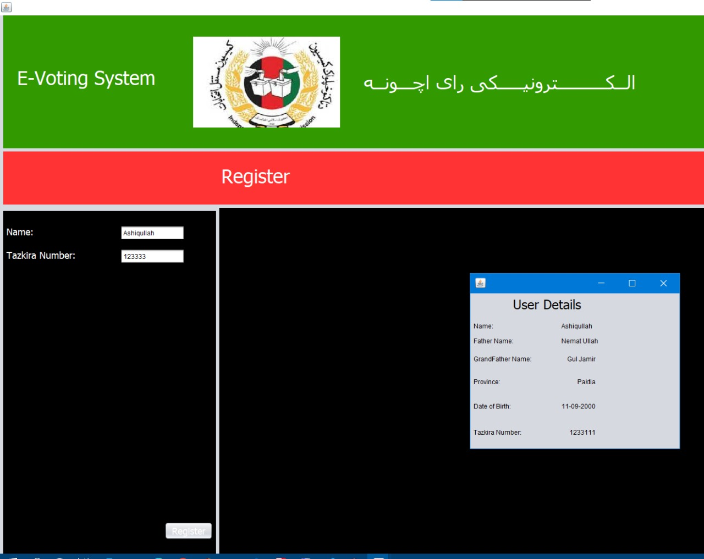

* **Display Candidate:**

In this part every candidate would be displayed with detail information, which are ID, province, name and Tazkira number.

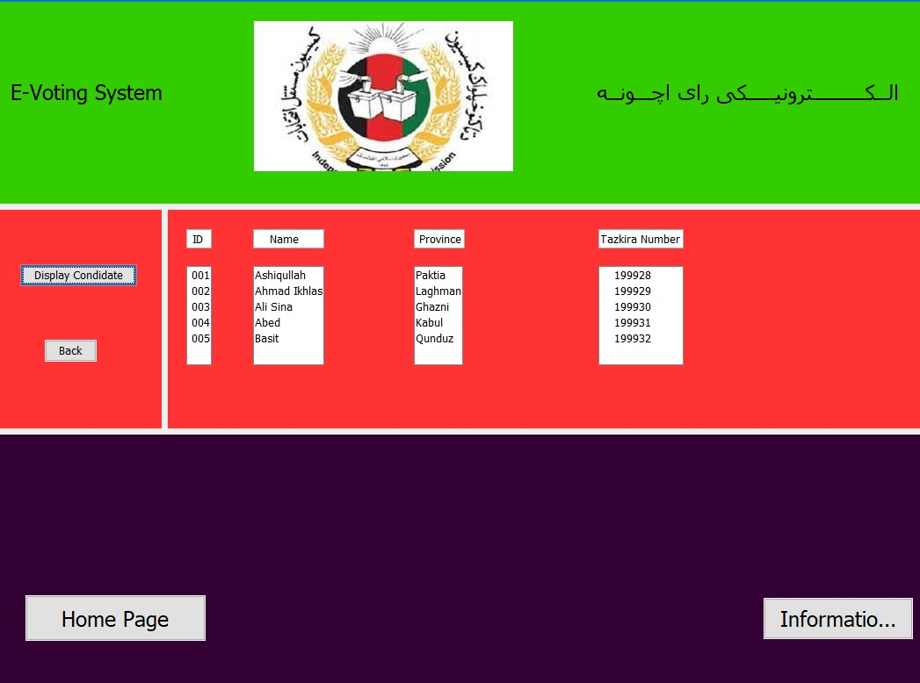

**Ahmad Ikhlas Safi (SP21-BSE-088)**

* **Caste vote:**

In this part the voter give the vote to their favorite candidate. By selecting the candidate and entering their CNIC number they can give vote.

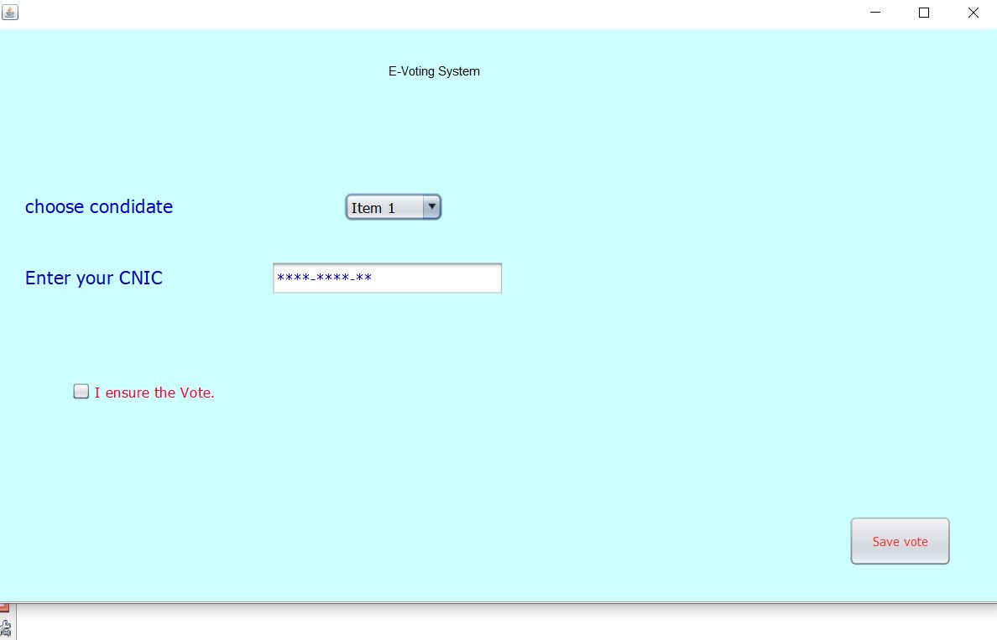

* **View Vote:**

In this part after the voter gave the vote, there will be a page and be displayed to the voter. By showing the voters name.

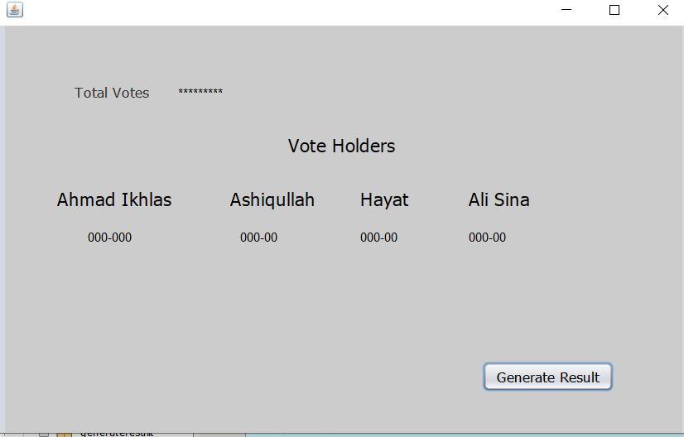

**Hayatullah (SP21-BSE-084)**

**Homepage:**

The homepage for the IEC will be following

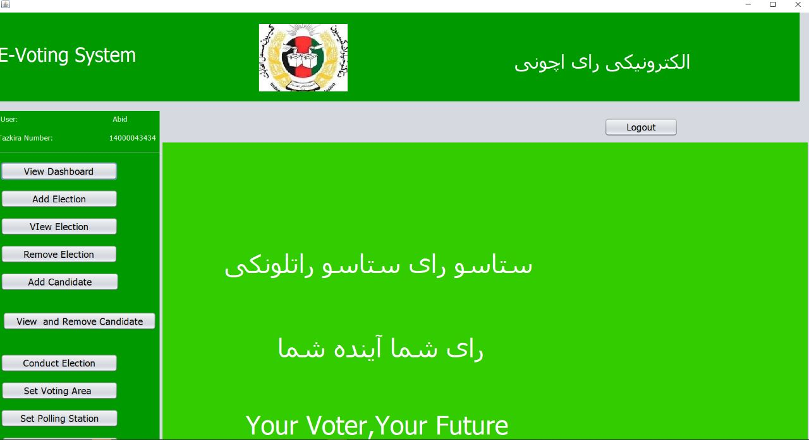

After clicking on the view and remove candidate following screen will be appear in which we can see the candidate name.

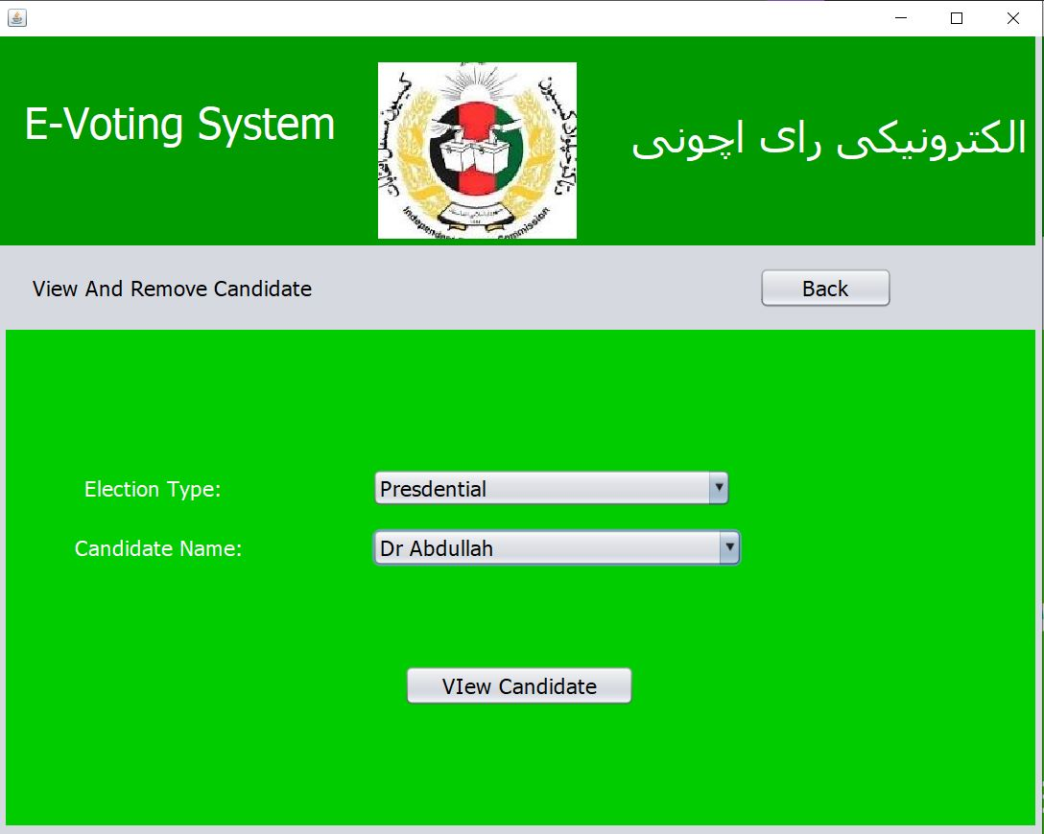

After clicking, on the View candidate the details of the candidate will be appear on the screen and if the click on back button it will be back to the homepage.

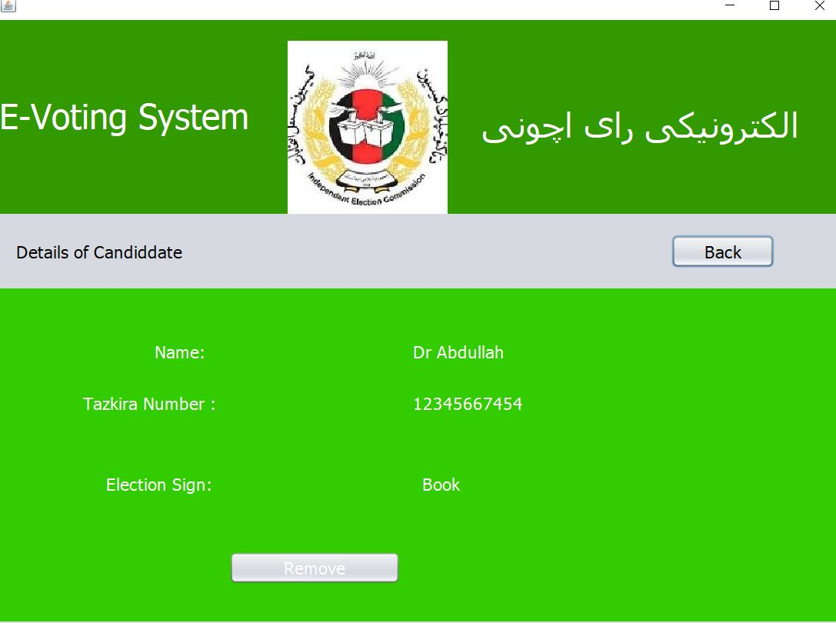

Clicking on the “Yes” it will remove automatically and if it click on no it will be back.

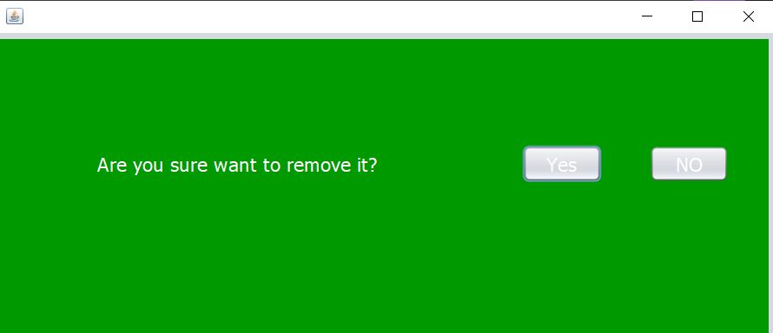

Clicking on “Yes” it will remove that and following screen will be appear.

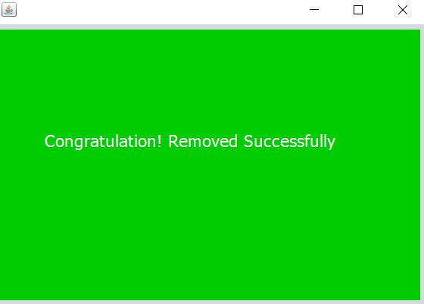

**Muhammad Bilal FA20-BSE-071**

